REGISTRATION APPLICATION 2021-22
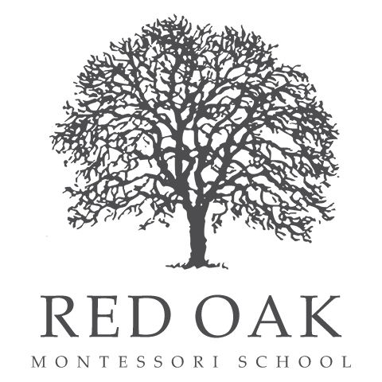
Today’s Date _________________
Non-refundable registration fee: $125
(Check payable to “Red Oak”)

OFFICE USE: Registration Paid: Check # _______or Cash ____ $_________ Date ____________

Student & Family Information

Child’s Name __________________________Date of Birth ___________
Address: ___________________________________ City _______________ Zip _______

Parent(s)/Guardian(s) with whom child resides:

Name: ____________________
Phone _____________________
E-mail _____________________
Name: ____________________
Phone _____________________
E-mail _____________________

Other Adults (name/relationship) in household:___________________________
Non-resident Parent name/contact: ___________________________________

Program Enrollment -- please select both Days and Times:
___ 5 DAY: (M-F)
___ 4 DAY (circle: M, T, W, Th, F) ___ 3 DAY (circle: M, T, W, Th, F)
___ Full-Day: 8:00 am-3:30 pm
___ Half-Day: 8:00 am-12:00 pm

Questions about schedule/program? Call 934-1002 or director@redoakmontessori.org
We accept NH Child Care Scholarship; information at https://nheasy.nh.gov
Additional Information (if child is new to Red Oak, such as a sibling) –
Child’s Name:

What attracted you to Montessori education/Red Oak Montessori School?

Has your child had prior pre-school or childcare experience? If so, where, and what was his/her experience there?

What are some activities that your child enjoys, activities you do as a family?

Are there any medical/learning/behavioral conditions that may affect your child’s school day?

Is there anything in your child’s life that might impact his/her experience at Red Oak?
e.g- fears, anxiety, stress etc.

Does your child have any activity or dietary restrictions?

Anything else you would like to tell us about your child that will help enhance his/her experience at Red Oak?

Red Oak Montessori School does not discriminate on the basis of race, color, gender, religion, disability, sexual orientation, national and/or ethnic origin in the admissions process, its educational policies, programs, and activities, tuition assistance, or employment

