RED OAK SUMMER CAMP
Red Oak Montessori School, 241 Sanborn Street in Franklin
Announcing an 8-week summer program, June 21 to August 13,
for children ages 3 to 7 years ~ from 8am to 3:30pm Mon-Fri!
Children may attend from 5 to all 8 weeks,
and may attend 3 or 5 days per week.
Full Week (5-days/week) = $200/week
Half Week (3-days/week) = $165/week
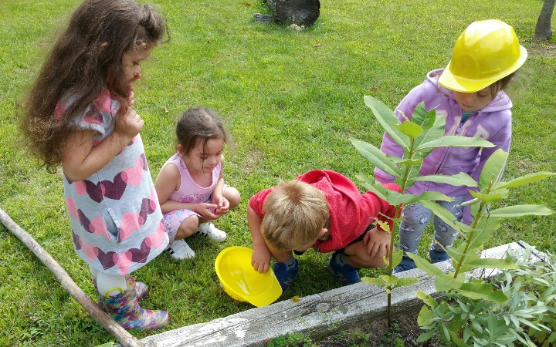
A FEW spaces are available, beyond Red Oak’s current and alumni students who have already signed up.
CONTACT Red Oak to visit, and pick up a summer camp registration and permission forms:
934-1002 or director@redoakmontessori.org or Message our Facebook page.
Although children will utilize the classroom, Montessori lessons and materials will not be the program.
Each week will feature a theme; most activities will be outdoors!
More details forthcoming soon, such as eight-week and multiple-child discounts.
Children will LOVE coming to “summer camp” with Ms. Nicole and Evan!
